# **Stronger2 Community of Practice – The Learning Network**

Stronger2 is an initiative that aims to decrease health inequities within Black/African Immigrant & Hispanic/Latino focus communities, improve access to & use of culturally appropriate COVID-19 mitigation strategies, and enhance resilience and empowerment in communities, leading to overall improved health outcomes.

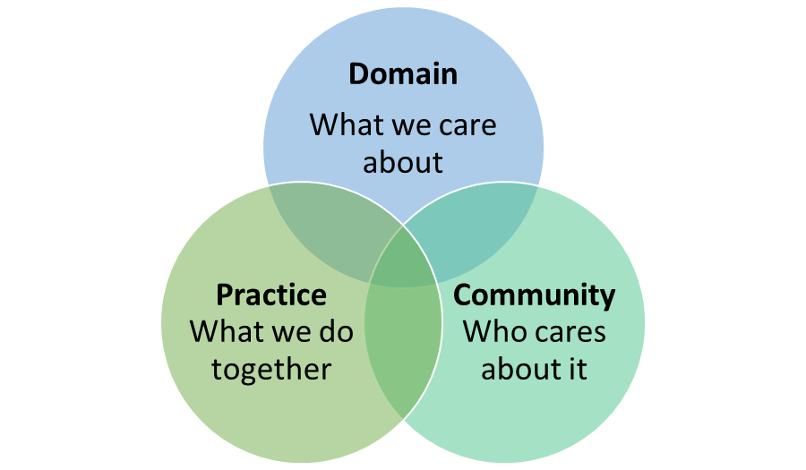

**Community of Practice Components**

Within a [Community of Practice](https://youtu.be/XS1OhxXhOEM) (CoP), a group of people connect in a co-learning process about a shared issue or passion. In this case, it’s to improve health outcomes, decrease inequities and increase resilience within Hispanic and Black/African Immigrant communities. Participants determine the agenda and topics they will explore, as well as serve as presenters themselves practice. To be successful, it requires ongoing interaction, to maintain a connection to the overarching goal and other community members.

**Linkages to Stronger2 Capacity Building Plan**

**A critical part of the Stronger2 initiative, this provides Implementation Partners an opportunity to share information related to project activities; encourages collaboration and assists staff and volunteers to start and sustain their learning. In addition, the CoP promotes Implementation Partners’ work through discussions, best practices and shared experiences, while and encouraging the use of this new knowledge for changes and improvement.**

**Learning Network (CoP) Goals**

Increase COVID-19 Mitigation Capacity

* Integrate health literacy resources
* Implement core activities
* Create messaging
* Navigate community members to resources
* Manage programs
* Evaluate, adapt and sustain initiative

**Logistics**

**The Institute of Public Health Innovation staff coordinate the monthly 1.5-hour distance-based participatory discussions. They work with members to set the agenda, determine presenters, and facilitate conversations.**

**Contact**

**Gloria Buame, Institute for Public Health Innovation: gbuame@institutephi.org**

|  |  |  |  |
| --- | --- | --- | --- |
| **Work plan** | | | |
| **Activity/Task** | **Person** | **Date** | **Notes** |
| Develop slides | Joanna Davis | January 13, 2022 6:30 pm | **Theme: Introduction and Level-Setting** |
| Set up Zoom Meeting | Joanna Davis | January 13, 2022 6:30 pm |  |
| Facilitate meeting | Joanna Davis | January 13, 2022 6:30 pm |  |
| Evaluate participant response | Joanna Davis | January 30, 2022 |  |
| Develop slides | Joanna Davis | February X, 2022 | **Theme: Spotlight Presentation: Barber Shop Health Literacy Training Strategy** |
| Set up Zoom Meeting | Joanna Davis | February X, 2022 |  |
| Facilitate meeting | Joanna Davis | February X, 2022 |  |
| Evaluate participant response | Joanna Davis | February X, 2022 |  |
| Develop slides | Gloria Buame | March X, 2022 | Theme: Project Updates & Facilitated Discussion |
| Set up Zoom Meeting | Gloria Buame | March X, 2022 |  |
| Facilitate meeting | Gloria Buame | March X, 2022 |  |
| Evaluate participant response | Gloria Buame | March X, 2022 |  |
| Develop slides | Gloria Buame | April X, 2022 | Theme: Project Updates & Facilitated Discussion |
| Set up Zoom Meeting | Gloria Buame | April X, 2022 |  |
| Facilitate meeting | Gloria Buame | April X, 2022 |  |
| Evaluate participant response | Gloria Buame | April X, 2022 |  |
| Develop slides | Gloria Buame | May X, 2022 | Theme: Spotlight Presentation |
| Set up Zoom Meeting | Gloria Buame | May X, 2022 |  |
| Facilitate meeting | Gloria Buame | May X, 2022 |  |
| Evaluate participant response | Gloria Buame | May X, 2022 |  |
| Develop slides | Gloria Buame | June X, 2022 | **Project Updates & Facilitated Discussion** |
| Set up Zoom Meeting | Gloria Buame | June X, 2022 |  |
| Facilitate meeting | Gloria Buame | June X, 2022 |  |
| Evaluate participant response | Gloria Buame | June X, 2022 |  |
| Develop slides | Gloria Buame | July X, 2022 | **Project Updates & Facilitated Discussion** |
| Set up Zoom Meeting | Gloria Buame | July X, 2022 |  |
| Facilitate meeting | Gloria Buame | July X, 2022 |  |
| Evaluate participant response | Gloria Buame | July X, 2022 |  |
| Develop slides | Gloria Buame | August X, 2022 | **Project Updates & Facilitated Discussion** |
| Set up Zoom Meeting | Gloria Buame | August X, 2022 |  |
| Facilitate meeting | Gloria Buame | August X, 2022 |  |
| Evaluate participant response | Gloria Buame | August X, 2022 |  |
| Develop slides | Gloria Buame | September X, 2022 | Theme: Spotlight Presentation |
| Set up Zoom Meeting | Gloria Buame | September X, 2022 |  |
| Facilitate meeting | Gloria Buame | September X, 2022 |  |
| Evaluate participant response | Gloria Buame | September X, 2022 |  |
| Develop slides | Gloria Buame | October X, 2022 | **Project Updates & Facilitated Discussion** |
| Set up Zoom meeting | Gloria Buame | October X, 2022 |  |
| Facilitate meeting | Gloria Buame | October X, 2022 |  |
| Evaluate participant response | Gloria Buame | October X, 2022 |  |
| Develop slides | Gloria Buame | November X, 2022 | **Project Updates & Facilitated Discussion** |
| Set up Zoom meeting | Gloria Buame | November X, 2022 |  |
| Facilitate meeting | Gloria Buame | November X, 2022 |  |
| Evaluate participant response | Gloria Buame | November X, 2022 |  |
| Develop slides | Gloria Buame | December X, 2022 | Theme: Spotlight Presentation |
| Set up Zoom meeting | Gloria Buame | December X, 2022 |  |
| Facilitate meeting | Gloria Buame | December X, 2022 |  |
| Evaluate participant response | Gloria Buame | December X, 2022 |  |